SF.SmokeTestScripts_TC_SF_OBRequiredFieldsOnSalesStage_Instance1_12-Apr-2017_02-17-00_PM_Invoke_Application.png



SF.SmokeTestScripts_TC_SF_OBRequiredFieldsOnSalesStage_Instance1_12-Apr-2017_02-17-08_PM_Login.png

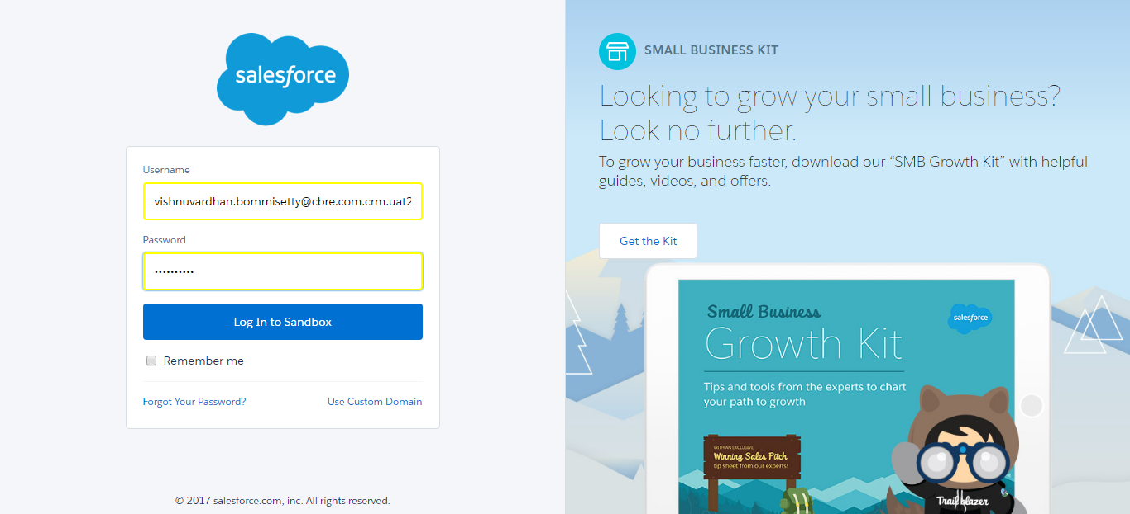

SF.SmokeTestScripts_TC_SF_OBRequiredFieldsOnSalesStage_Instance1_12-Apr-2017_02-17-16_PM_Verify_Login.png

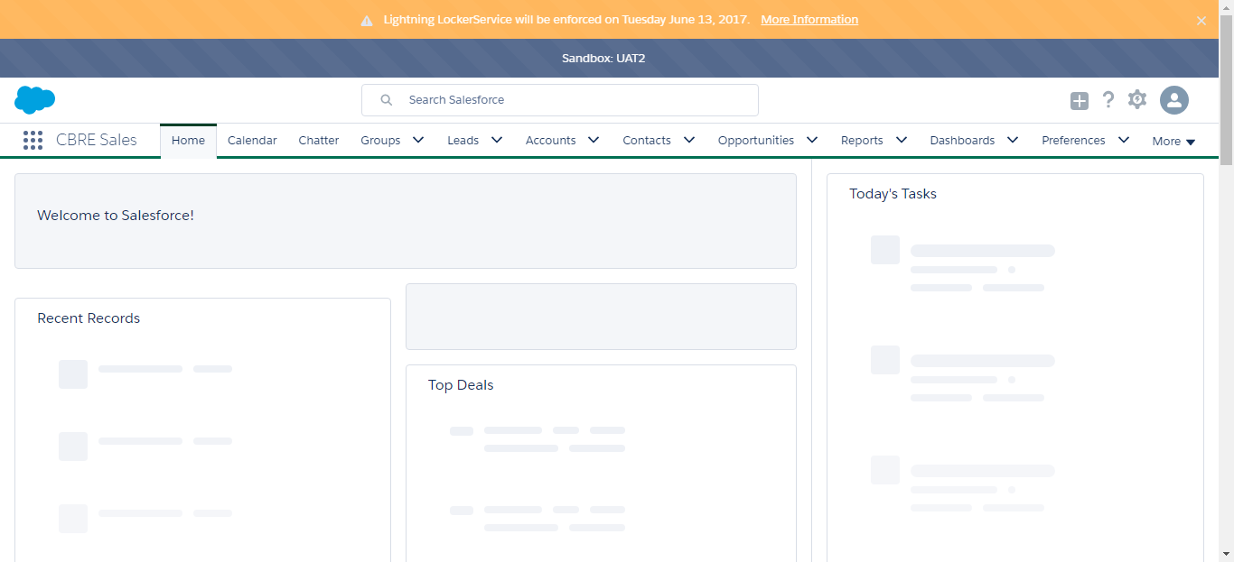

SF.SmokeTestScripts_TC_SF_OBRequiredFieldsOnSalesStage_Instance1_12-Apr-2017_02-17-17_PM_Verify_Fetch_Record.png

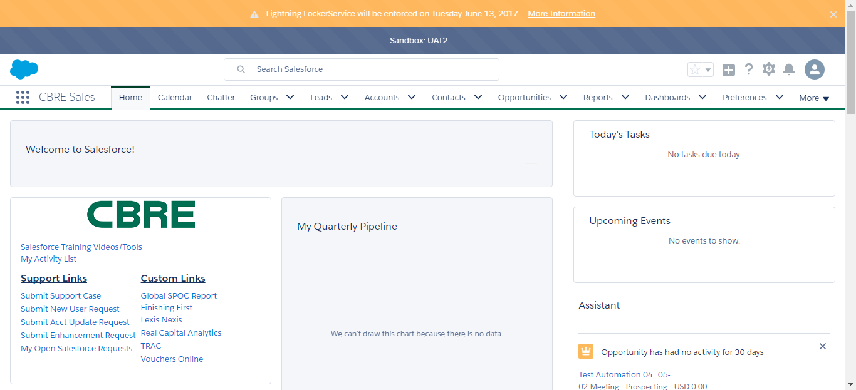

SF.SmokeTestScripts_TC_SF_OBRequiredFieldsOnSalesStage_Instance1_12-Apr-2017_02-17-20_PM_Verify_Opportunity_Required



SF.SmokeTestScripts_TC_SF_OBRequiredFieldsOnSalesStage_Instance1_12-Apr-2017_02-17-21_PM_Verify_Add_Opportunity_Page



SF.SmokeTestScripts_TC_SF_OBRequiredFieldsOnSalesStage_Instance1_12-Apr-2017_02-17-56_PM_Error.png

